Project Executable Files
Date | 01 October 2026
Team ID | SWTID-2026-2351
Project Name | Auto Ticket Classification using Flow Designer
Maximum Marks | 3 Marks

Step 1: Submission Checklist
S.No | Item to Submit | Submitted (Yes / No / NA)
1 | Complete source code (all files and folders) | Yes (Update Set XML)
2 | README / Setup Guide | Yes (this document)
3 | requirements.txt / package.json / dependency file | NA
4 | Database schema / seed files | Yes (inside Update Set)
5 | Environment configuration file | NA
6 | Deployed application URL | Yes (ServiceNow instance)
7 | APK / Executable binary | NA
8 | Dockerfile / Containerization config | NA
9 | Test files and test results | Yes (screenshots)
10 | Demo video or walkthrough | No (add if required)

Step 2: File / Folder Structure
- NAAN MUDHALVAN / MILESTONE1 to MILESTONE5: screenshots of each activity.
- MILESTONE5 / ACTIVITY1: Project Update Set XML (sys_remote_update_set_....xml) and its screenshot.

Step 3: Deployment / Access Details
Hosted / Deployed URL | Your ServiceNow instance URL (dev#####.service-now.com)
Login Credentials (Demo) | Provide the evaluator account here; do not share your admin password
Platform / Hosting Provider | ServiceNow Personal Developer Instance
Repository Link | Add link if uploaded
Demo Video Link | Add link if recorded

Step 4: Run Instructions
- Log in to the instance and search for Retrieved Update Sets.
- Import the Update Set XML, then Preview and Commit it.
- Open Incident Workflow > New and create a ticket with an empty Category.
- Check that Category and Subcategory are set and the confirmation email appears in Email Log.
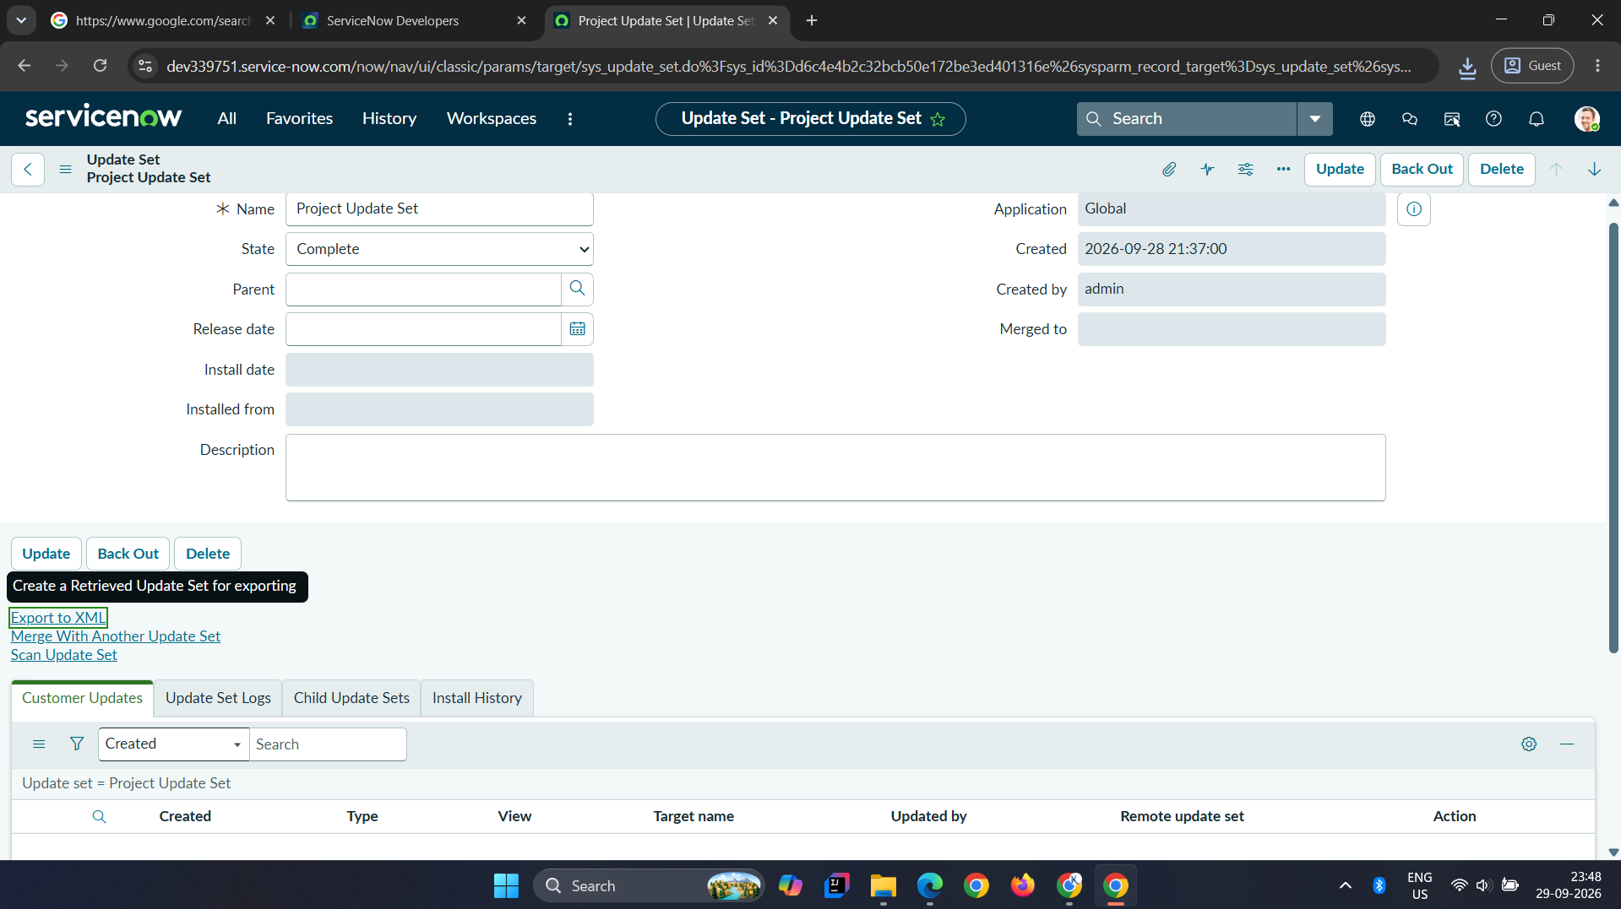
Figure 1: Project Update Set in Complete state with Export to XML

Step 5: Known Issues / Limitations
S.No | Known Issue / Limitation | Workaround / Status
1 | The exported XML shows only the update set record, with no captured customer updates in the file | Re-open the Update Set, confirm the Customer Updates tab lists the table, fields and flow, then export again
2 | Flow error handler is off | Enable it in a later iteration
3 | Keywords are fixed for four issue types | Add more If / Else If branches

